**CSCE 5580: Computer Network**

**Homework-2**

**Name:** Kishan Kumar Zalavadia

**EUID:** 11685261

1. **We have said that an application may choose UDP for a transport protocol because UDP offers finer application control (than TCP) of what data is sent in a segment and when.**
2. **Why does an application have more control over what data is sent in a segment?**

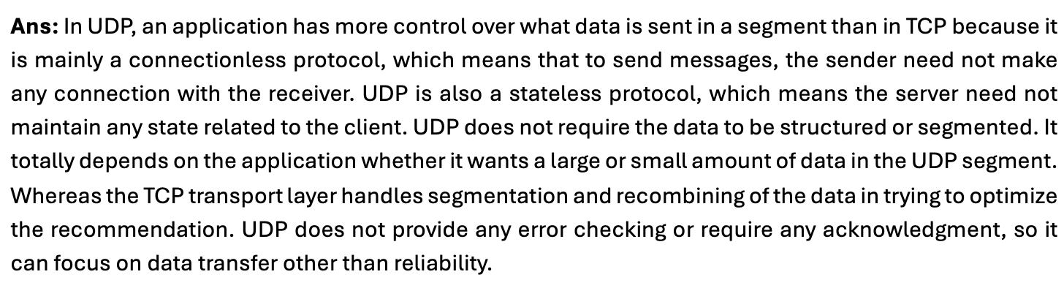**b. Why does an application have more control over when the segment is sent?**

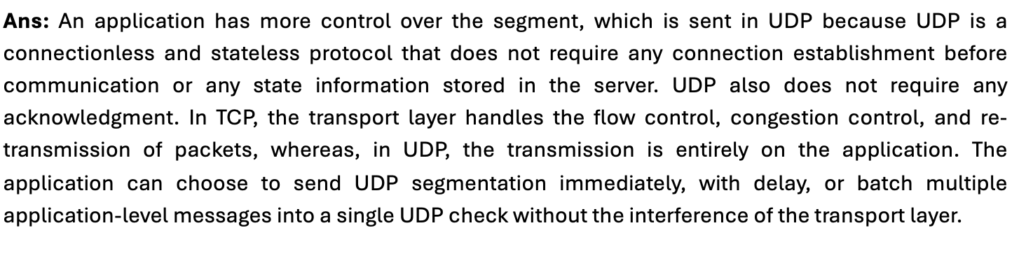

1. **Do a bit of research: Describe SYN flood attacks and how SYN cookies are used to help alleviate the problem. Use your own words rather than cut and paste from Wikipedia or other source.**

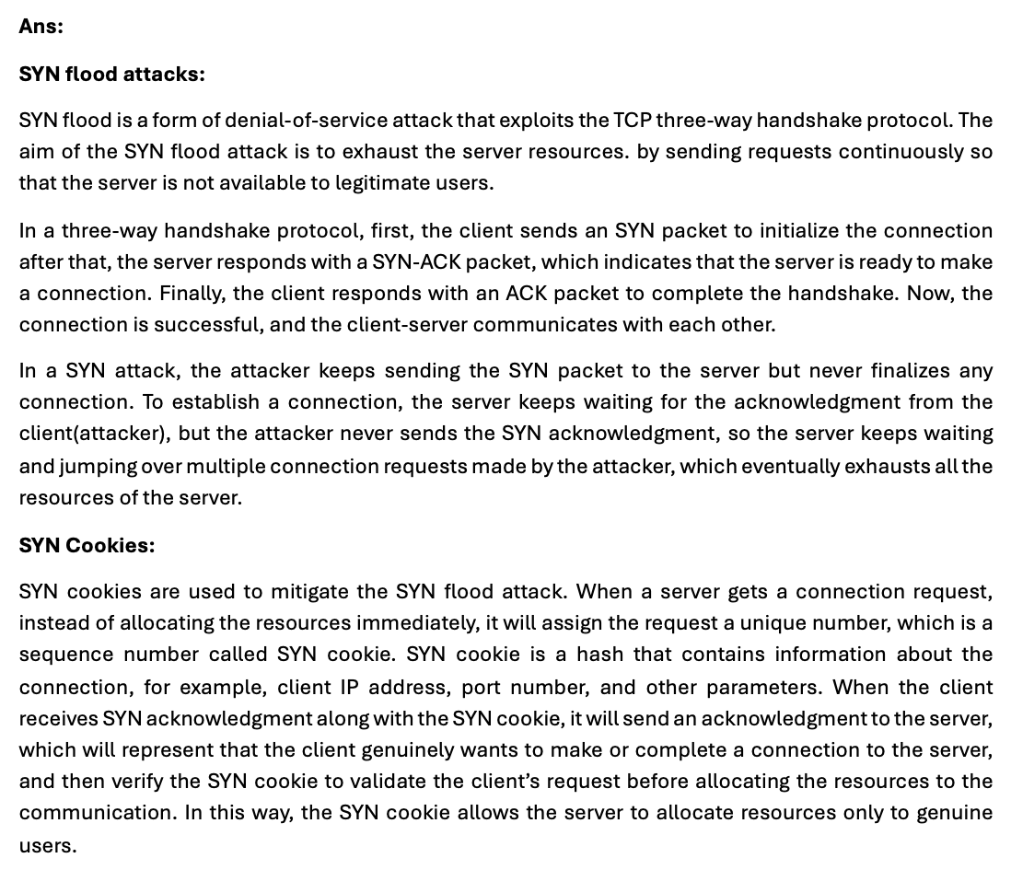

1. **What is the issue with not using sequence numbers in the TCP/IP protocol? List at least three example scenarios. Additionally, respond as to whether a reliable data transfer may be implemented on other layers of the TCP/IP protocol stack and issues that may arise from each.**

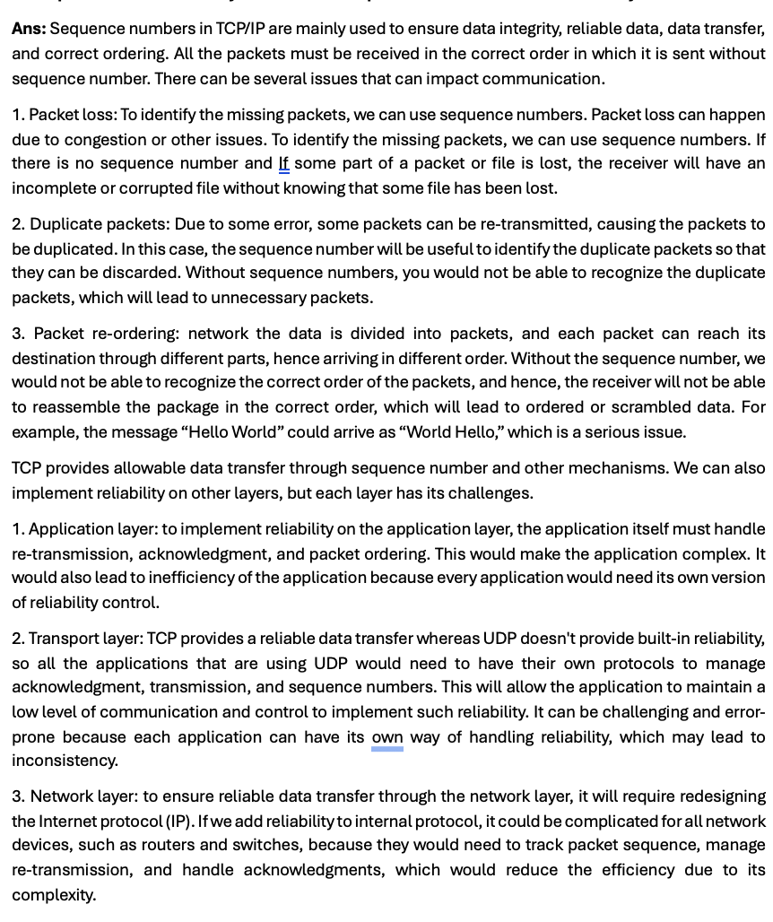

1. **Suppose that you have been assigned the 138.90.160.0/19 network address block, and you need to establish four equally-sized subnets from this block.**

**1) List the network addresses for each of the four subnets.**

**2) How many hosts can be in each subnet?**

**3) List the range of host IP addresses for the first subnet.**

**Ans:**

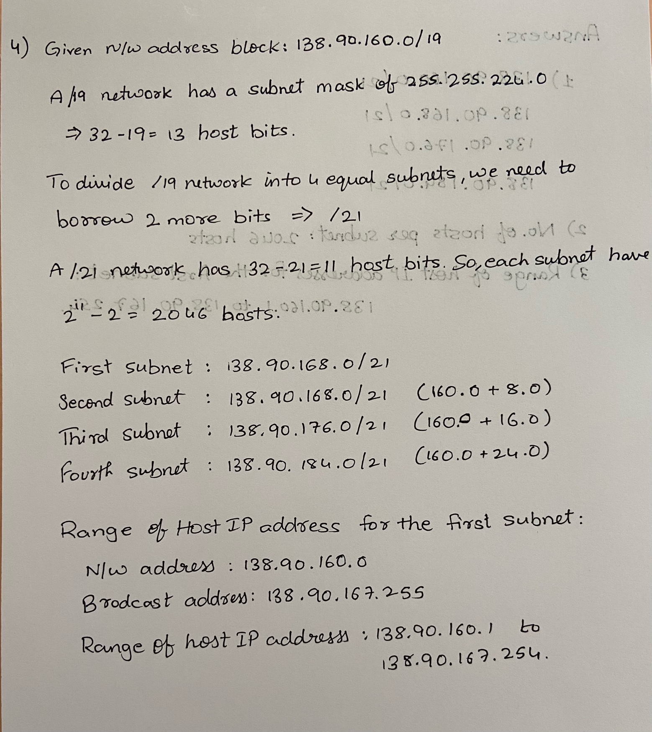

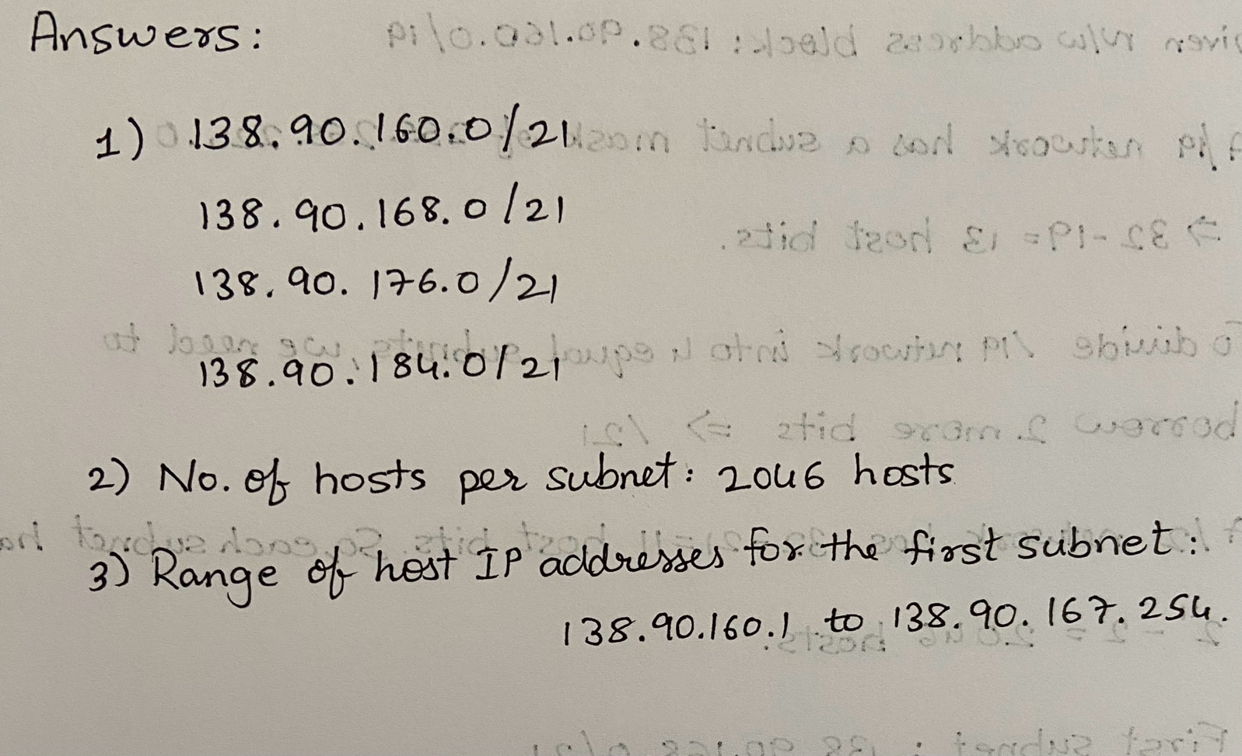

1. **Given the following computer networks,**

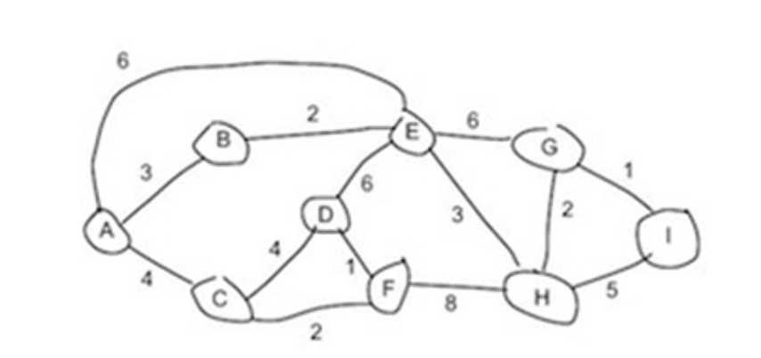

1. **Use Dijkstra’s shortest path algorithm to compute the shortest path from A to all network nodes. Show work/table. Show the final next hop routing table/forwarding table for A.**

**Ans:**

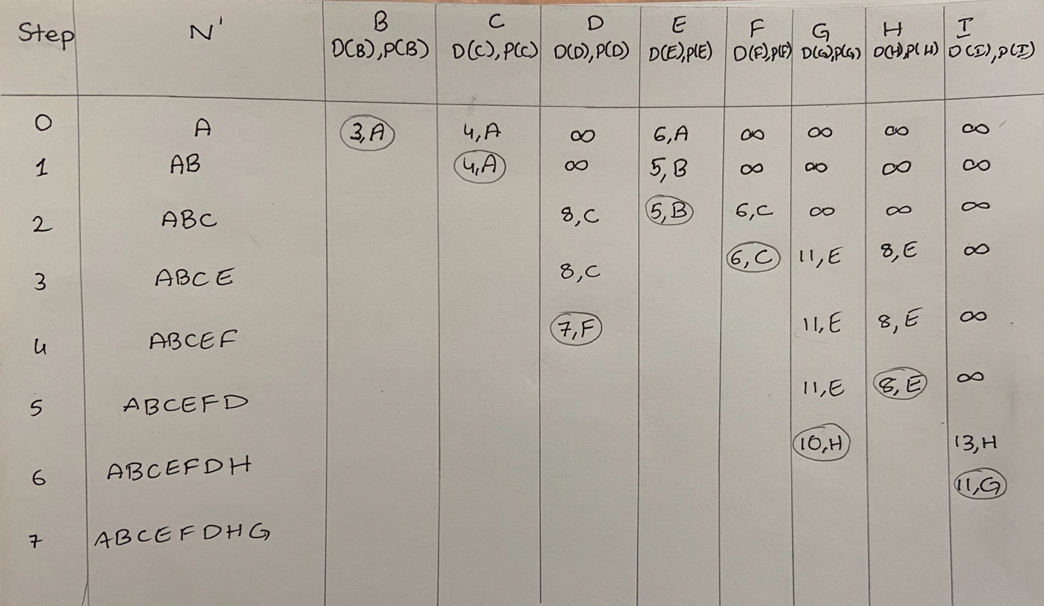

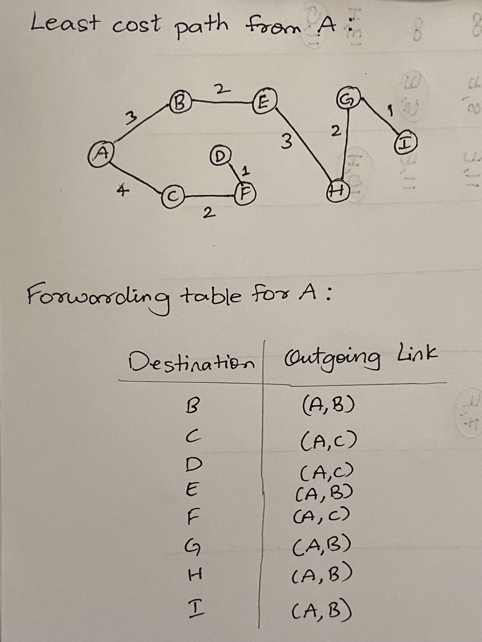

1. **Use the Bellman-Ford algorithm to show the shortest distance from each node to A. Show work/table. Show final next hop routing table values for each node to A. (Assuming that the algorithm begins with each node knowing only the costs to its immediate neighbors)**

**Ans:**

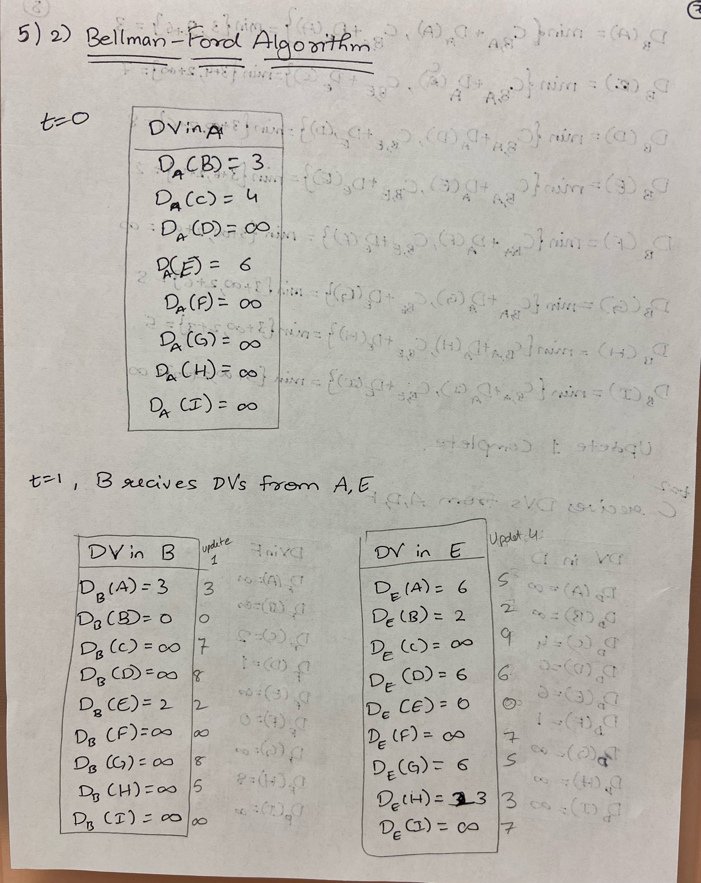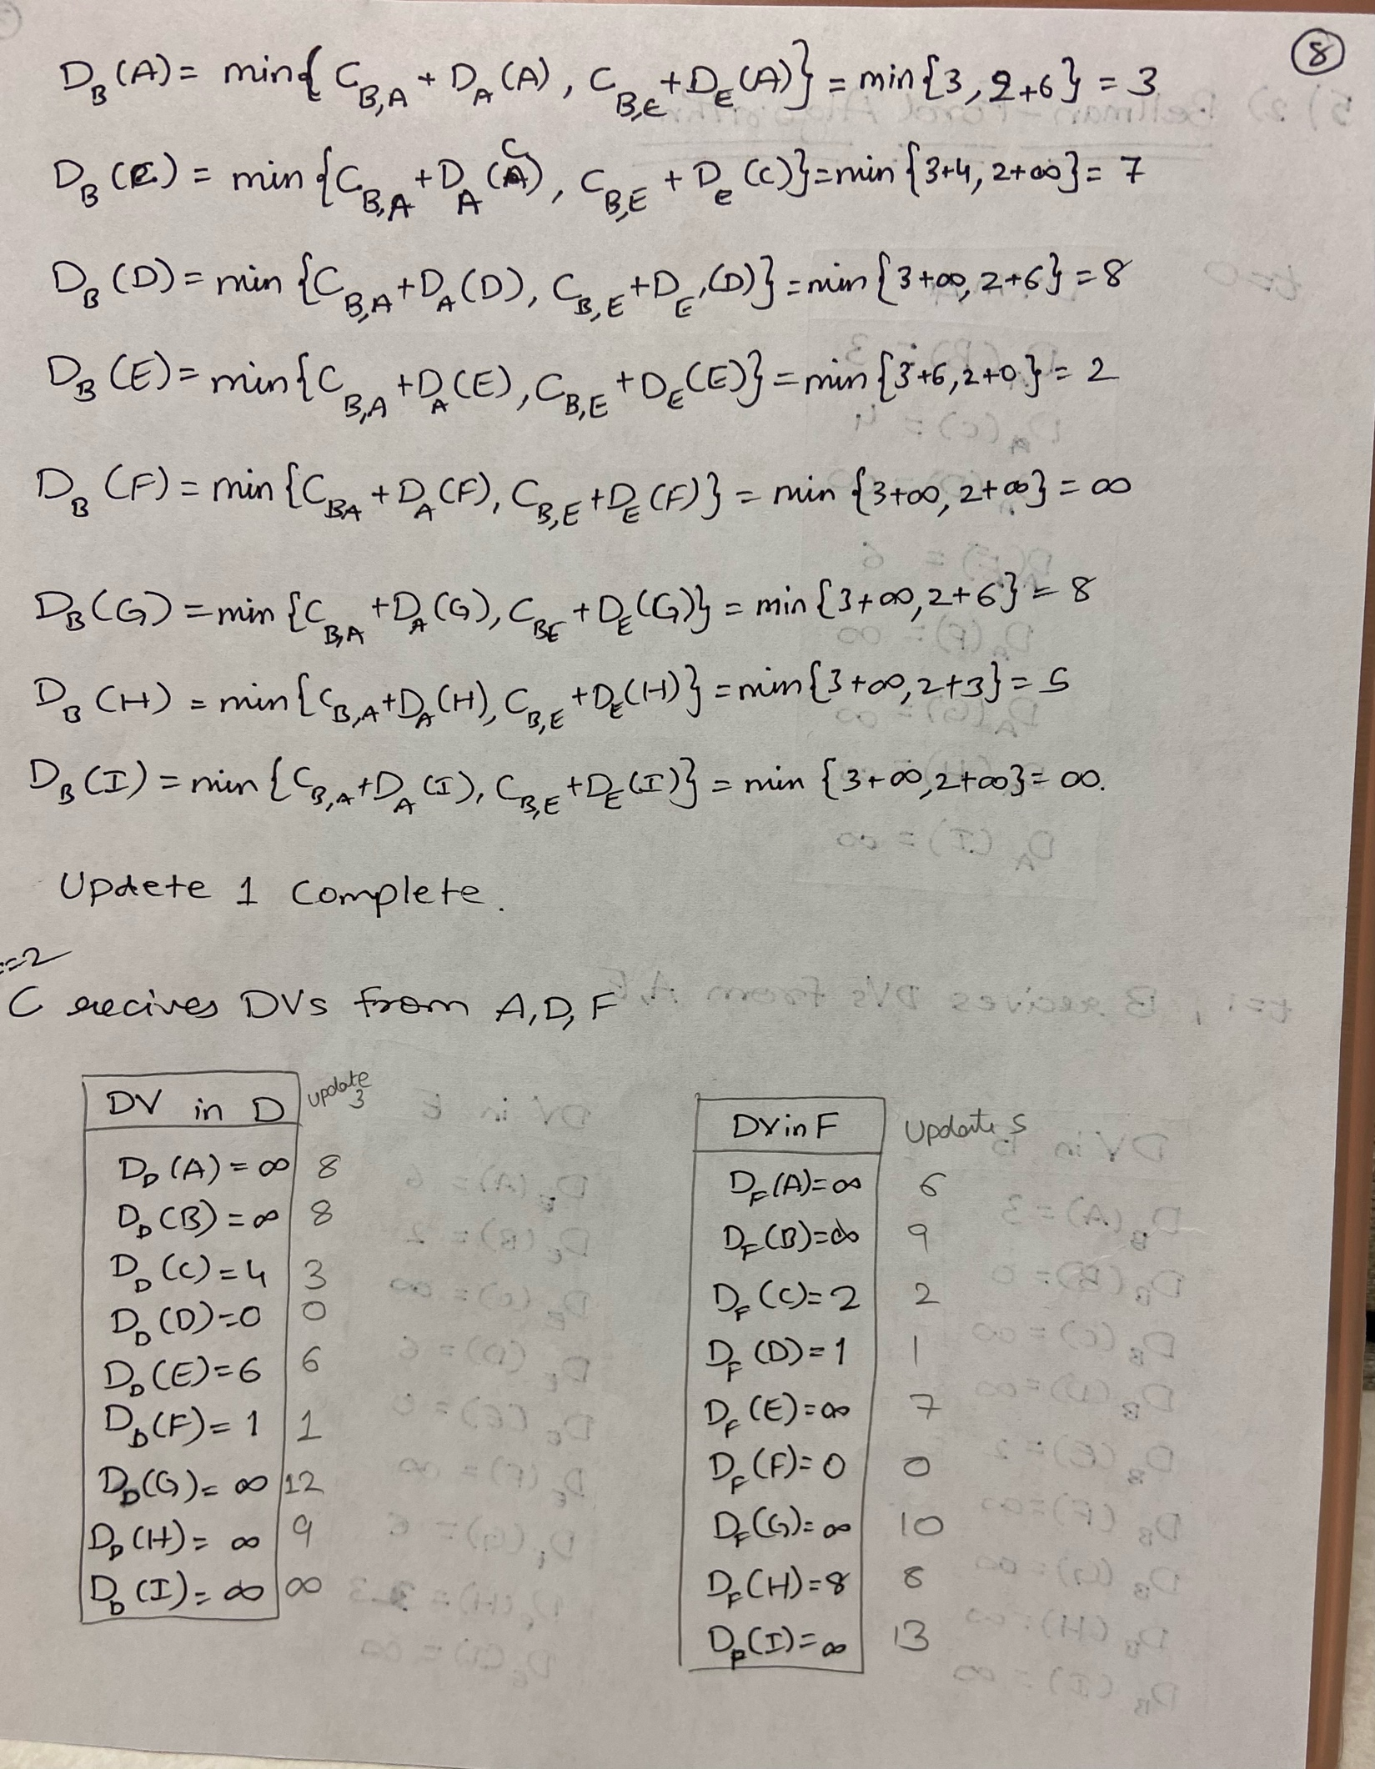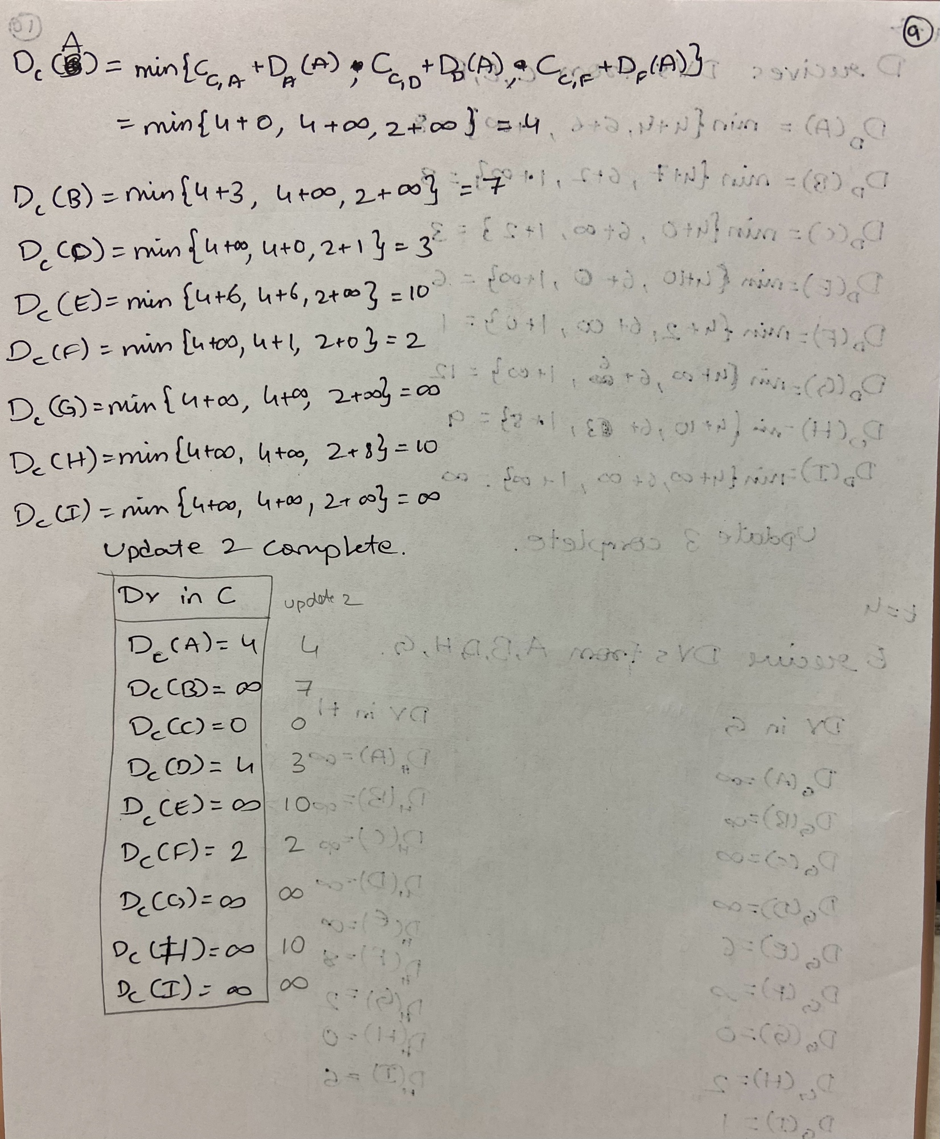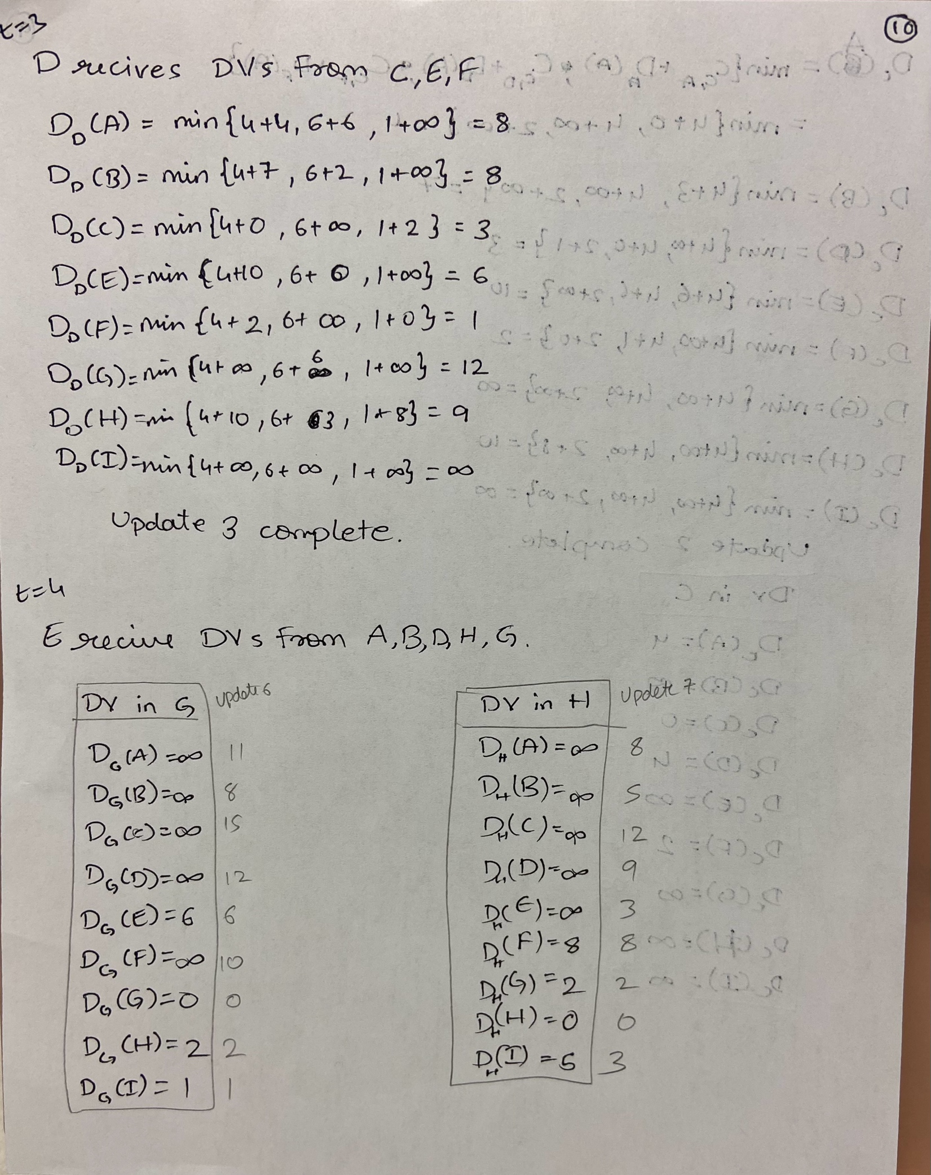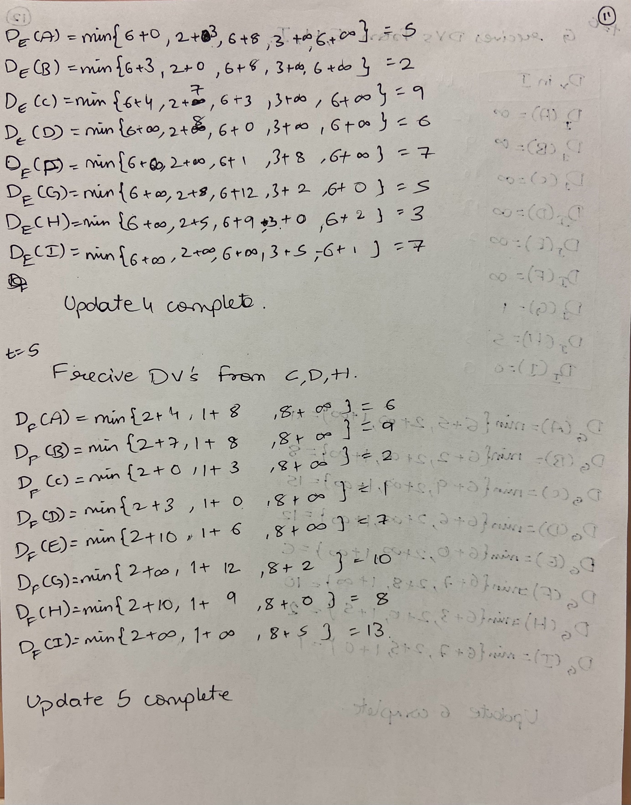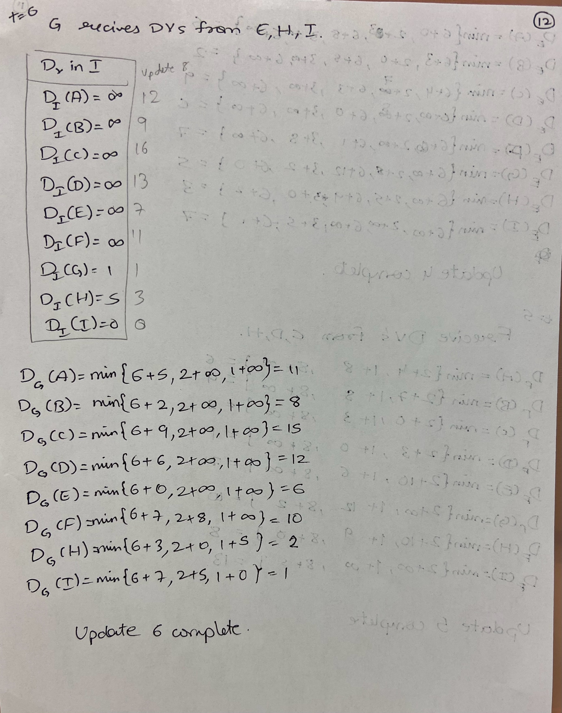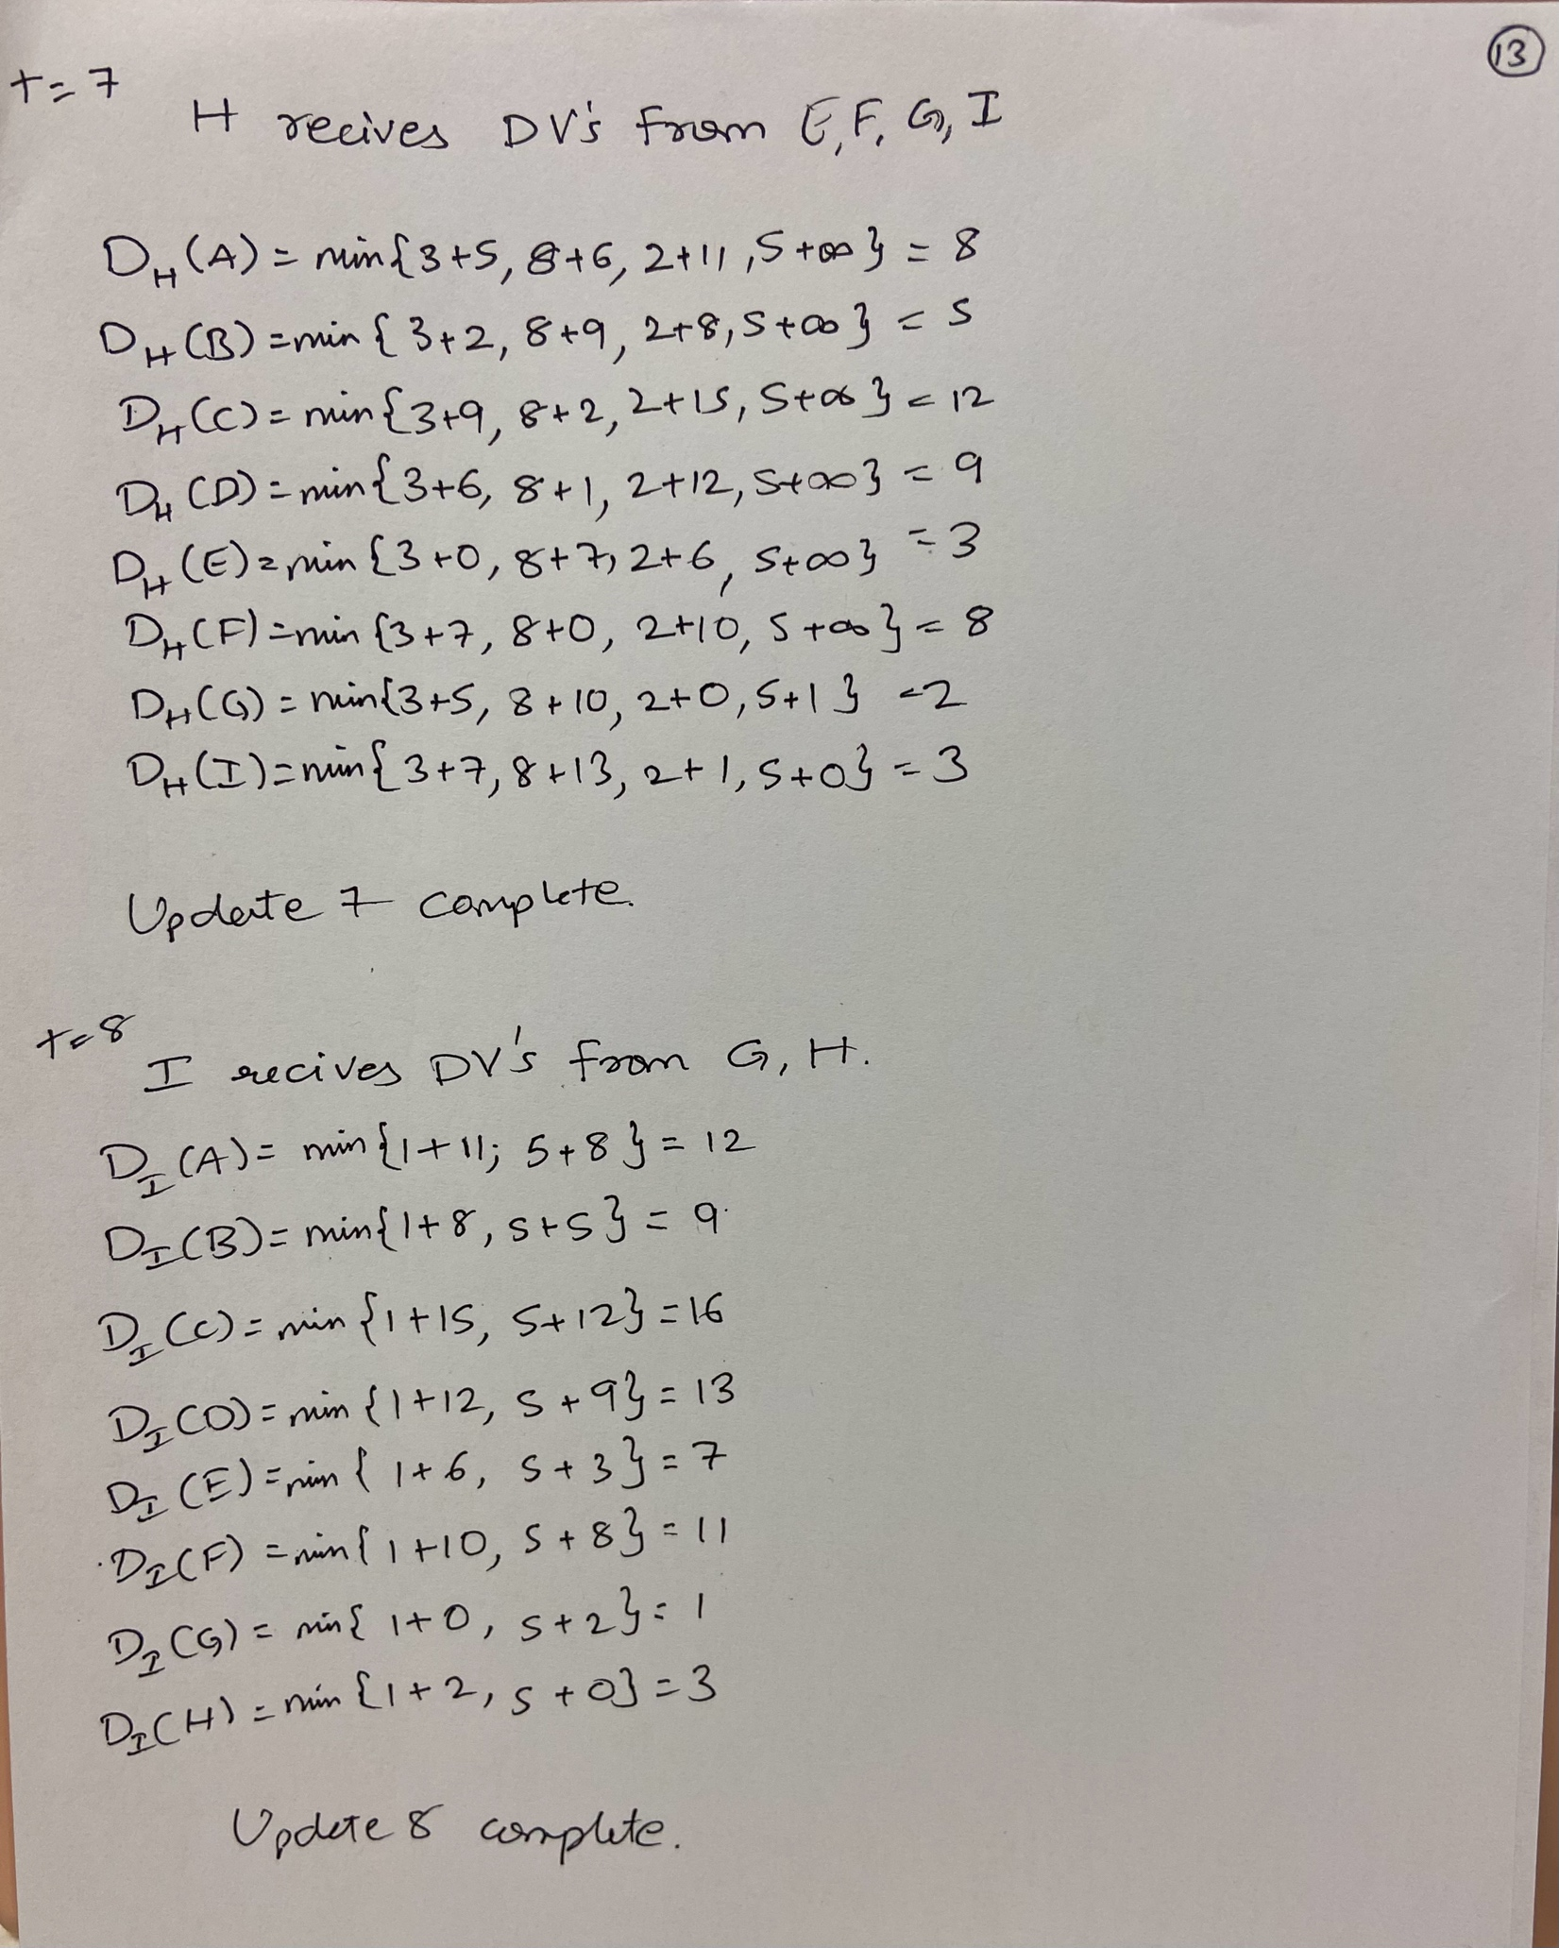

1. **Suppose a router interconnects three subnets. All of the subnets will have the prefix 211.1.16/24. Subnet 1 is required to support 62 interfaces, Subnet 2 will need to support 95 interfaces, and Subnet 3 will need to support up to 16 interfaces. Provide three network addresses of the form a.b.c.d/x that satisfy these constraints.**

**Ans:**

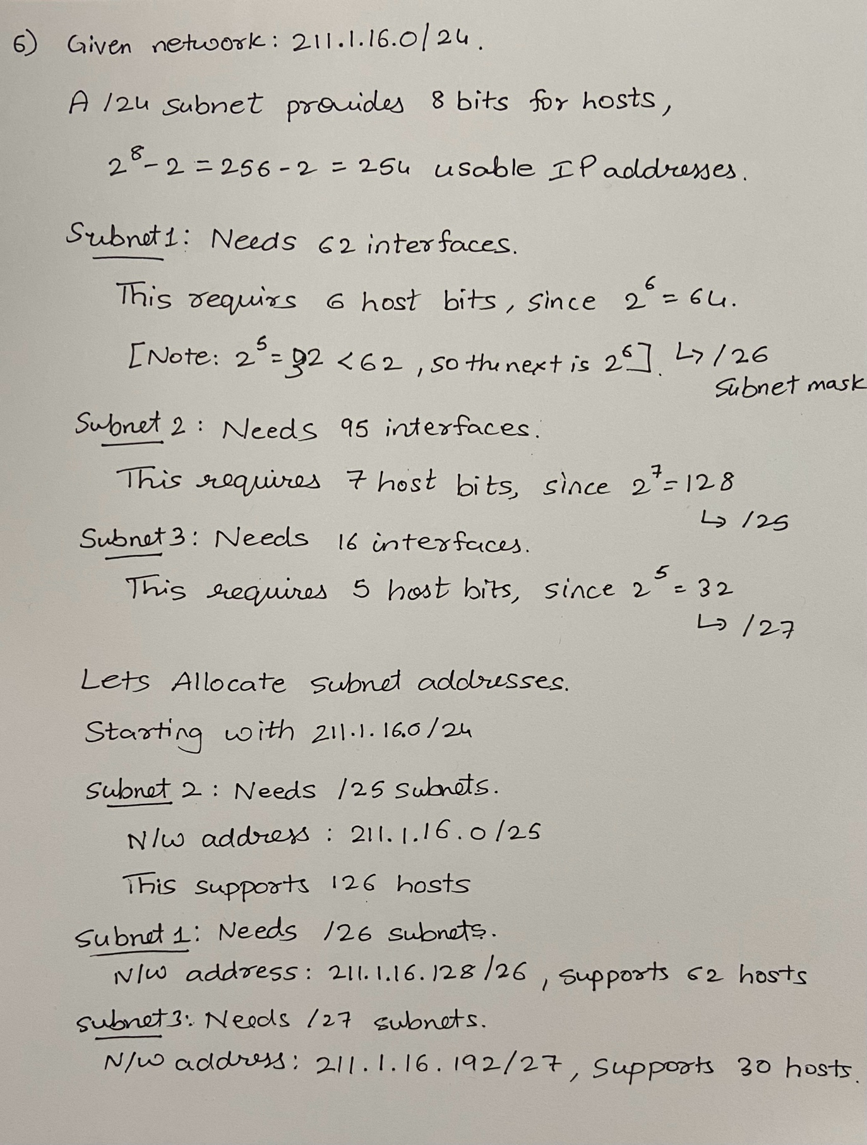

1. **You use** **Dijkstra’s algorithm for finding the shortest path in a graph between all pairs of nodes. Can you use the same algorithm and change it in some way to find the longest path?**

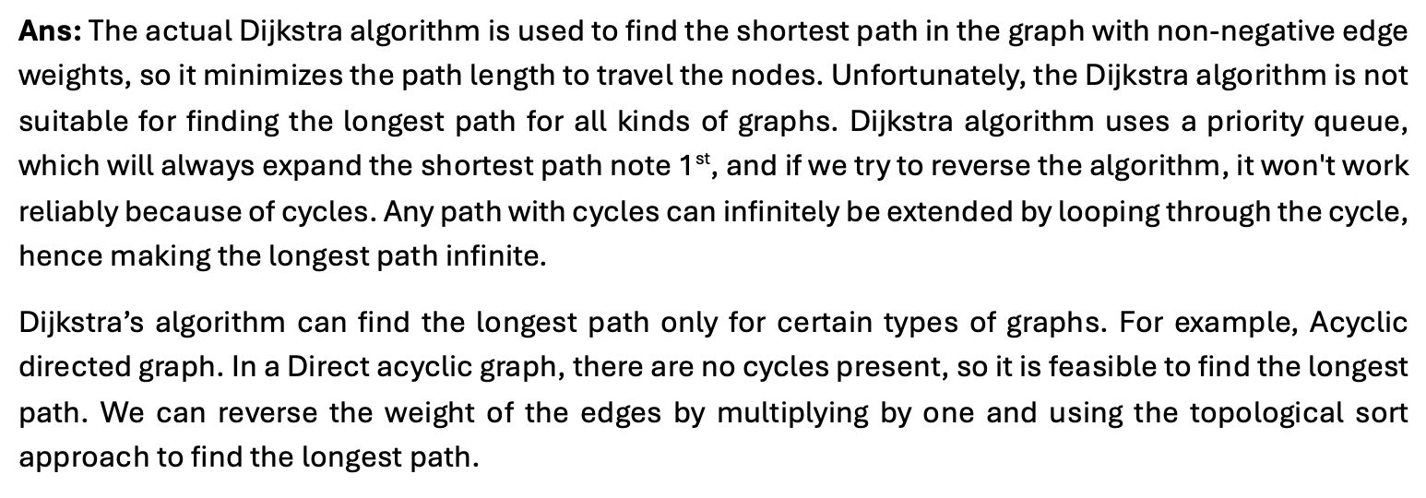

1. **Consider a general topology and a synchronous version of the distance-vector algorithm. Suppose that at each iteration, a node exchanges its distance vectors with its neighbors and receives their distance vectors. Assuming the algorithm begins with each node knowing only the costs to its immediate neighbors, what is the maximum number of iterations required before the distributed algorithm converges? Justify your answer**

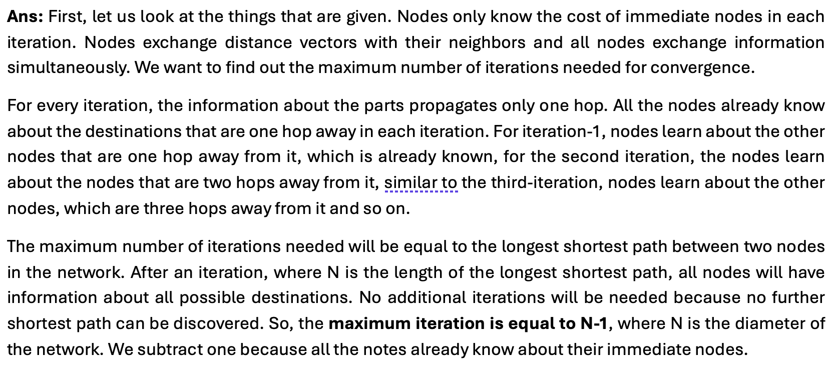

1. **Suppose you purchase a wireless router and connect it to your cable modem. Also, suppose that your ISP dynamically assigns your connected device (that is, your wireless router) one IP address. Also, suppose that you have five PCs at home that use 802.11 to wirelessly connect to your wireless router. How are IP addresses assigned to the five PCs? Does the wireless router use NAT? Why or why not?**

